HYPOTHESIS Generated FOR WiDS Dataset (2024):TNBC

Dt.17/5/24

Name: SOHAM .D MALI SRN:02FE22BCI025 Roll No. 23 WiDS Team No. 3 (D Div)

Team Name: Data Alchemists

1.We can see that Higher BMI is associated with Longer Metastatic Diagnosis Period. Therefore BMI can affect the patient’s body’s ability to fight cancer which can lead to delayed diagnosis.

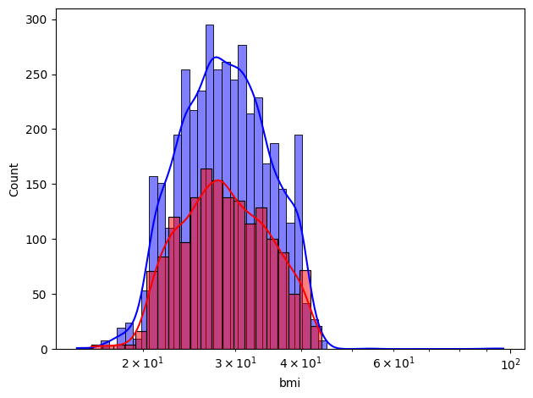

2.We can even say that Higher household income have shorter metastatic diagnosis period. So Higher income can be related with better access to healthcare and early diagnosis.

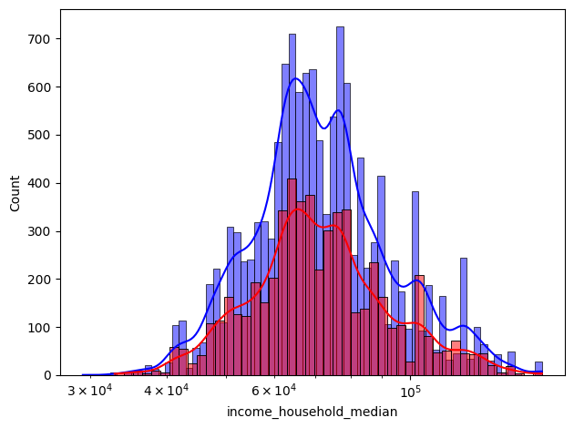

3.Age is also a major factor related to metastatic diagnosis period. That is Older patients might have other complications too which can lead to delay their cancer diagnosis.

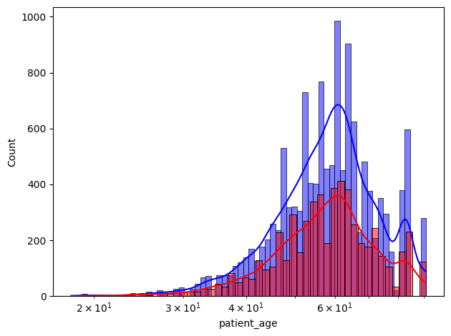

4.We can even say that Race and Ethnicity also may influence the Metastatic Diagnosis Period. It can so happen that healthcare access quality might result in different diagnosis times among different racial groups.

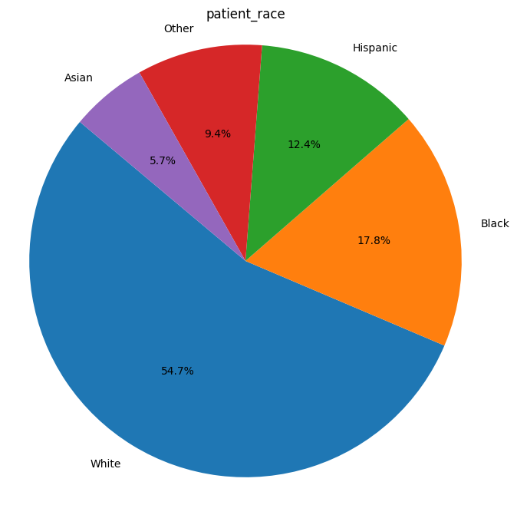

5.We can even say that Education level of a individual also affects the metatstatic diagnosis period.So Higher Education levels might correlate with better health literacy which can reduce the diagnosis duration which inturn will reduce the patients Diagnosis time.

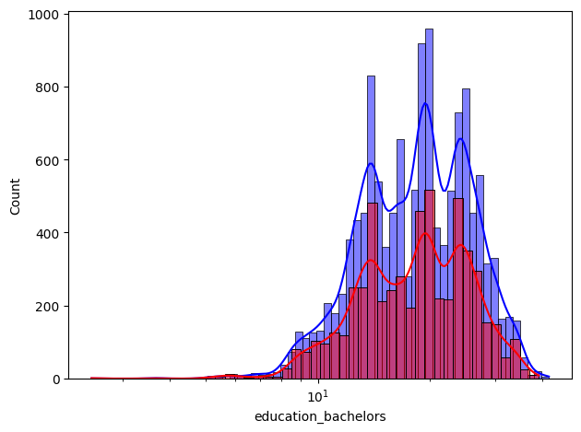

**🡪We can even reffer for more graphs for clear understanding and Analysis of attributes in our dataset.**